**S3 Bucket Policy**

S3 bucket policy is a resource-based AWS Identity and Access Management (IAM) policy. You add a bucket policy to a bucket to grant other AWS accounts or IAM users access permissions for the bucket and the objects in it. Object permissions apply only to the objects that the bucket owner creates.

Go to AWS s3 service

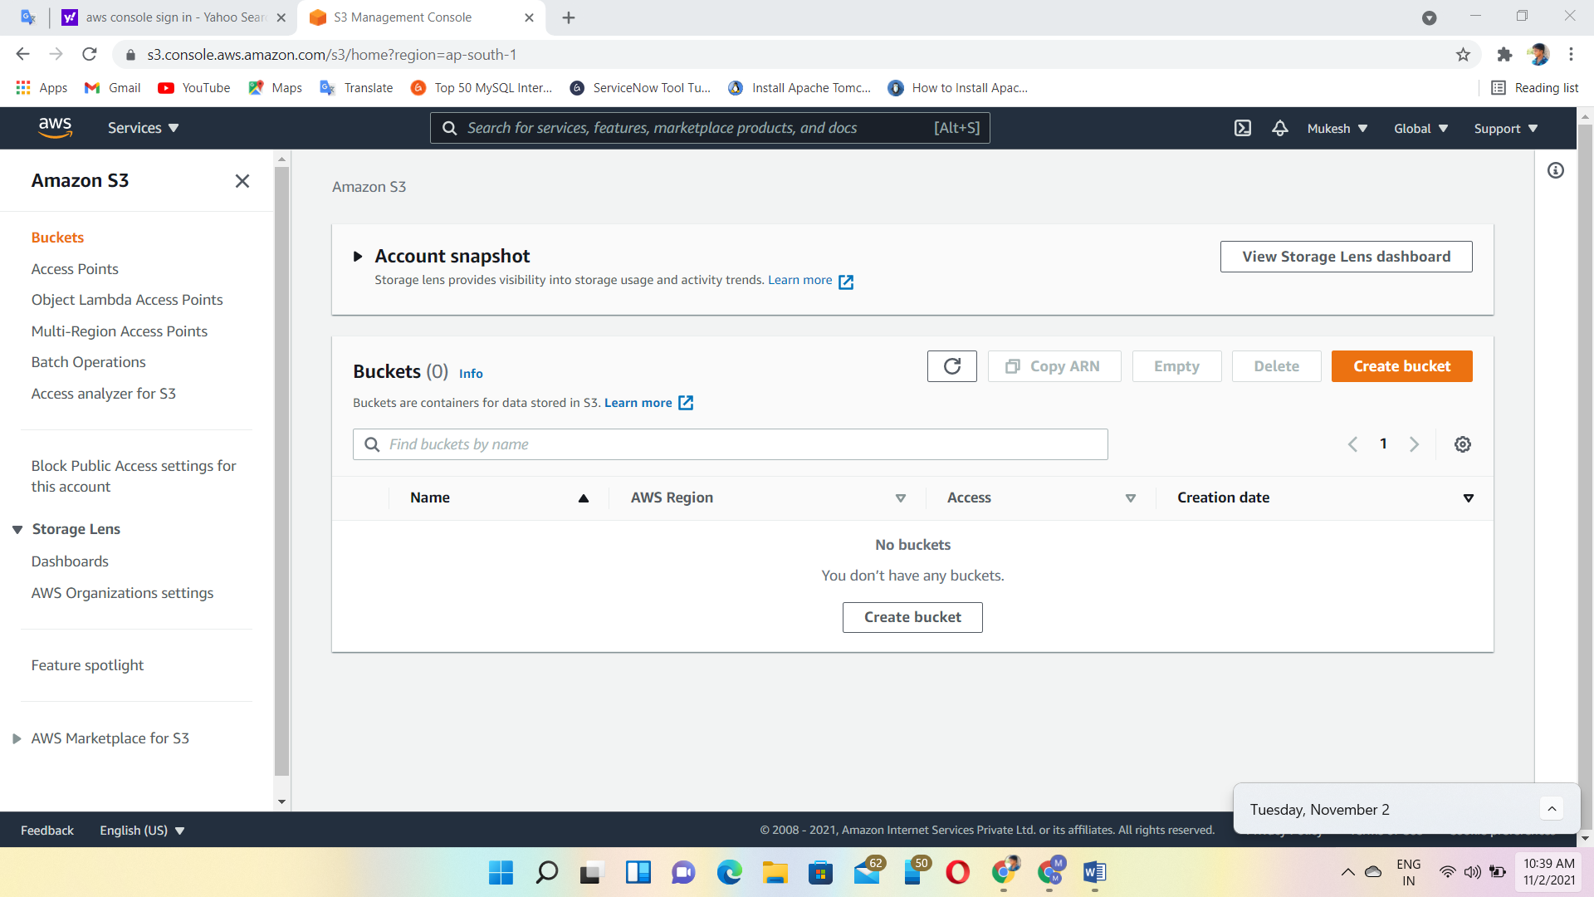

Create Bucket with unique name

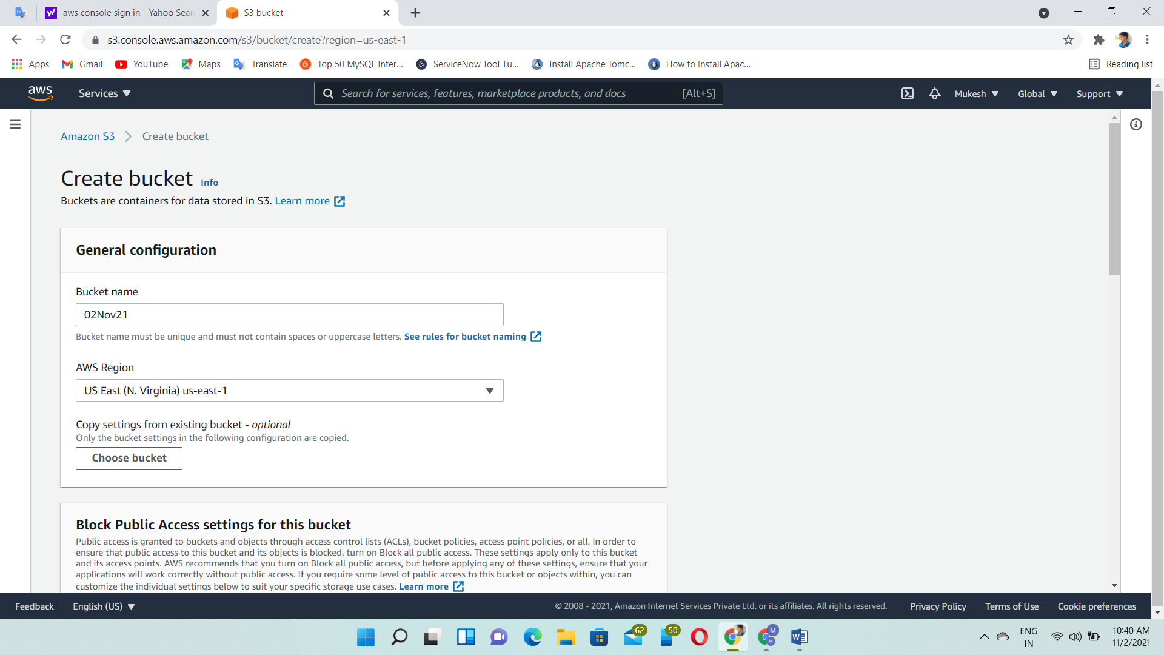

Upload any files you want

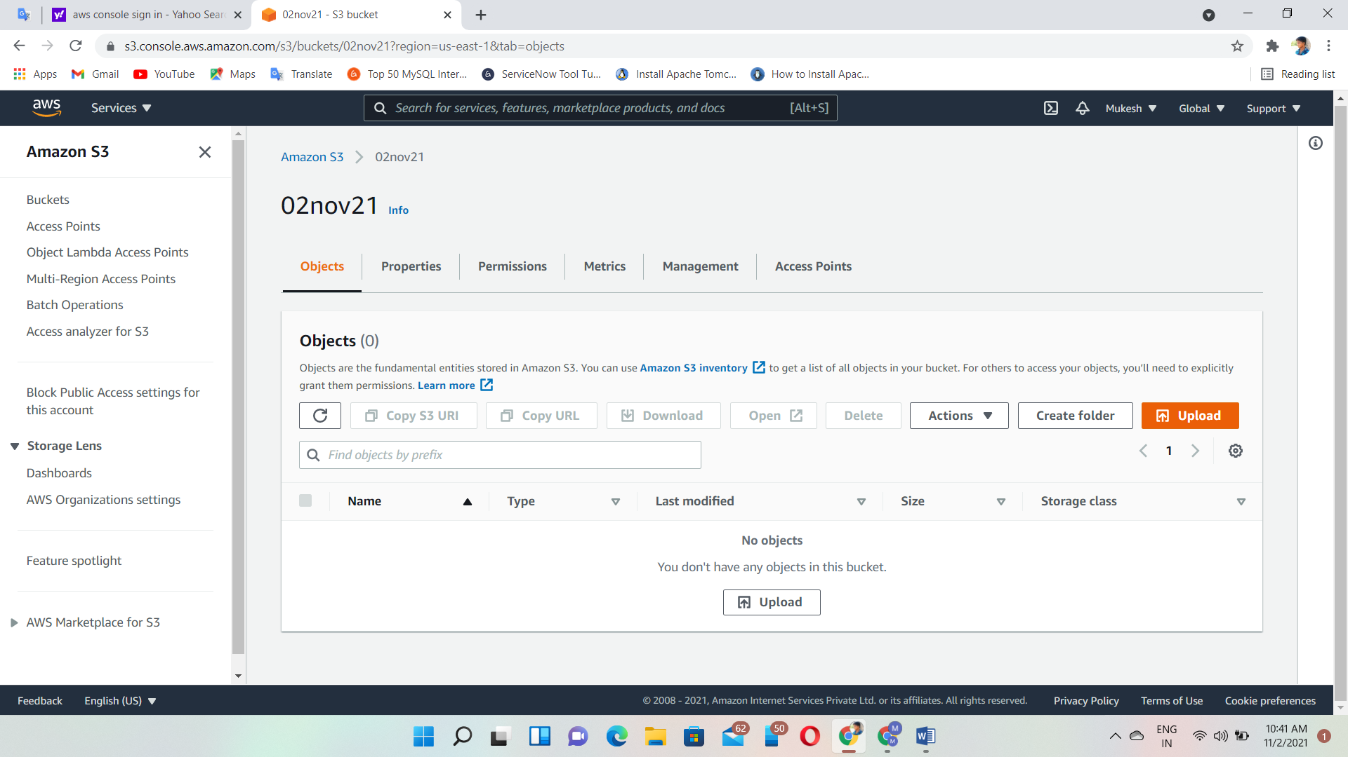

Click ‘add files’

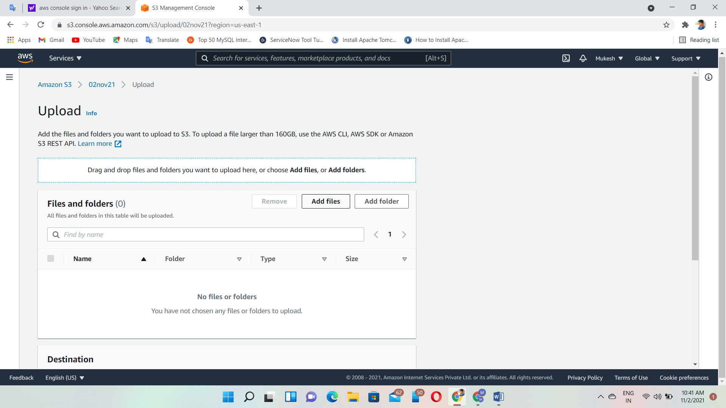

Uploading one image

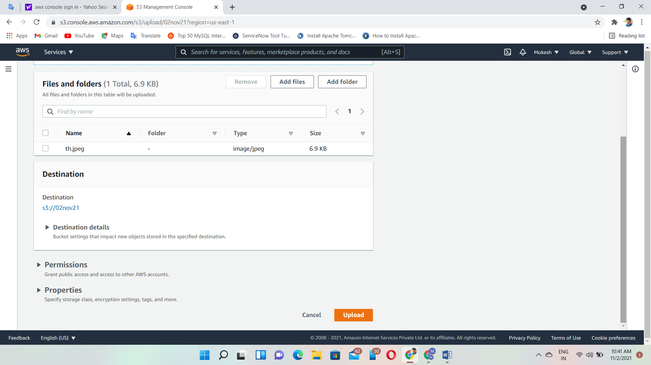

Successfully uploaded

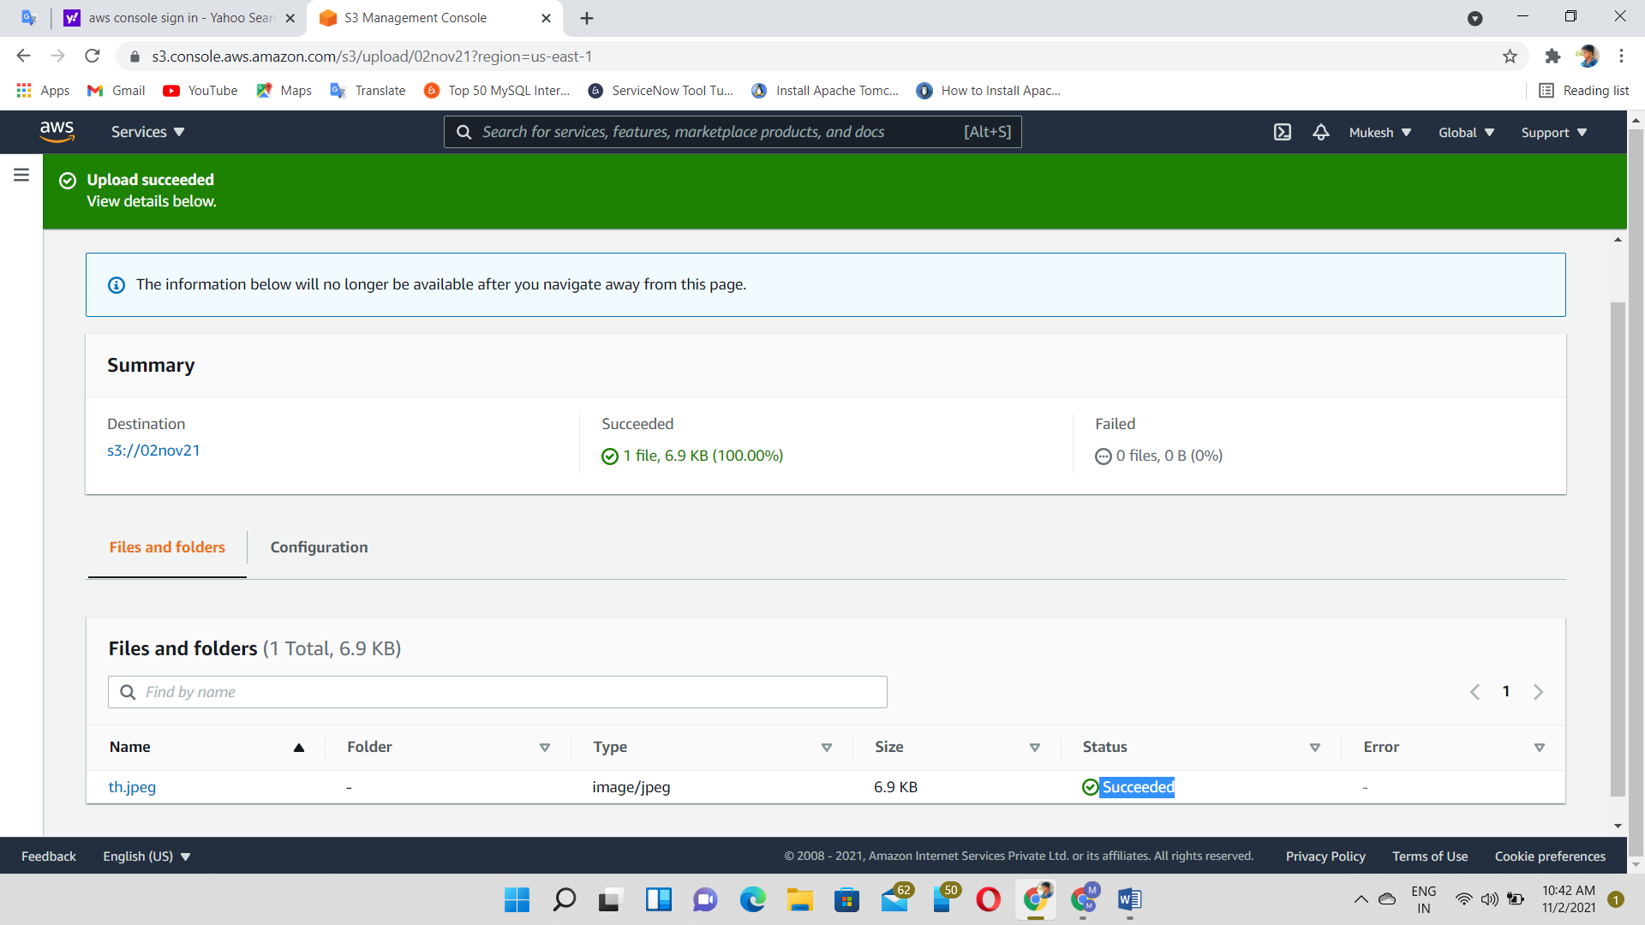

Go to bucket permission

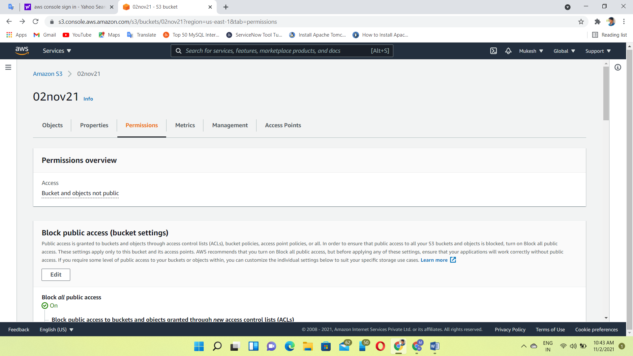

In Bucket 02nov21, Edit bucket policy

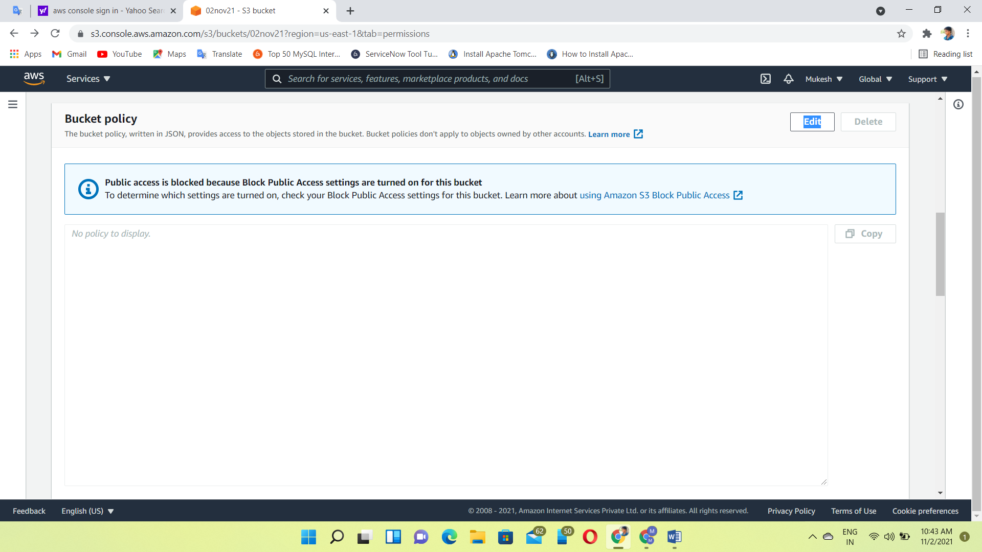

Click policy generator

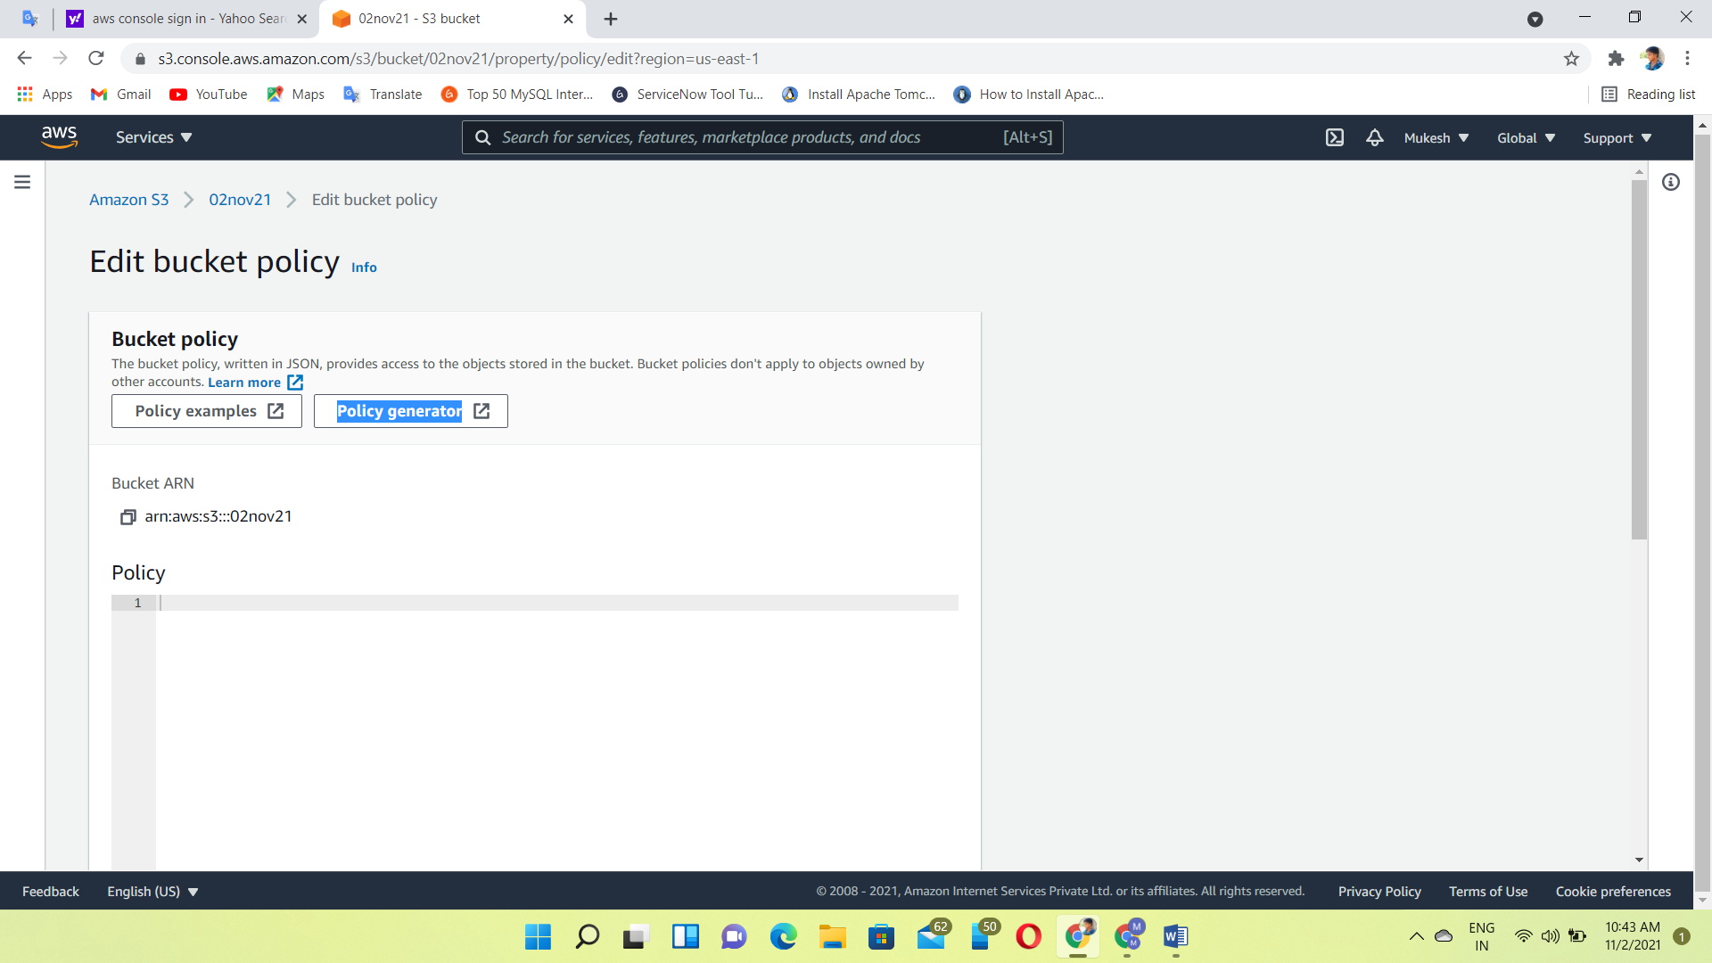

In policy generator, we have to give the permission policies

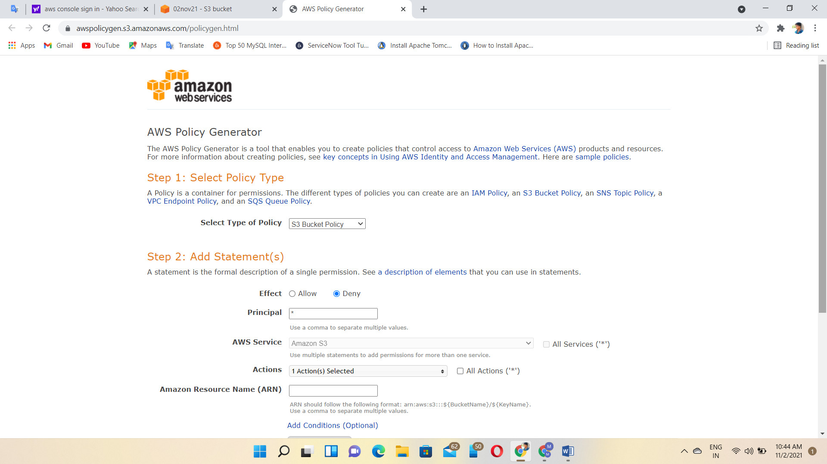

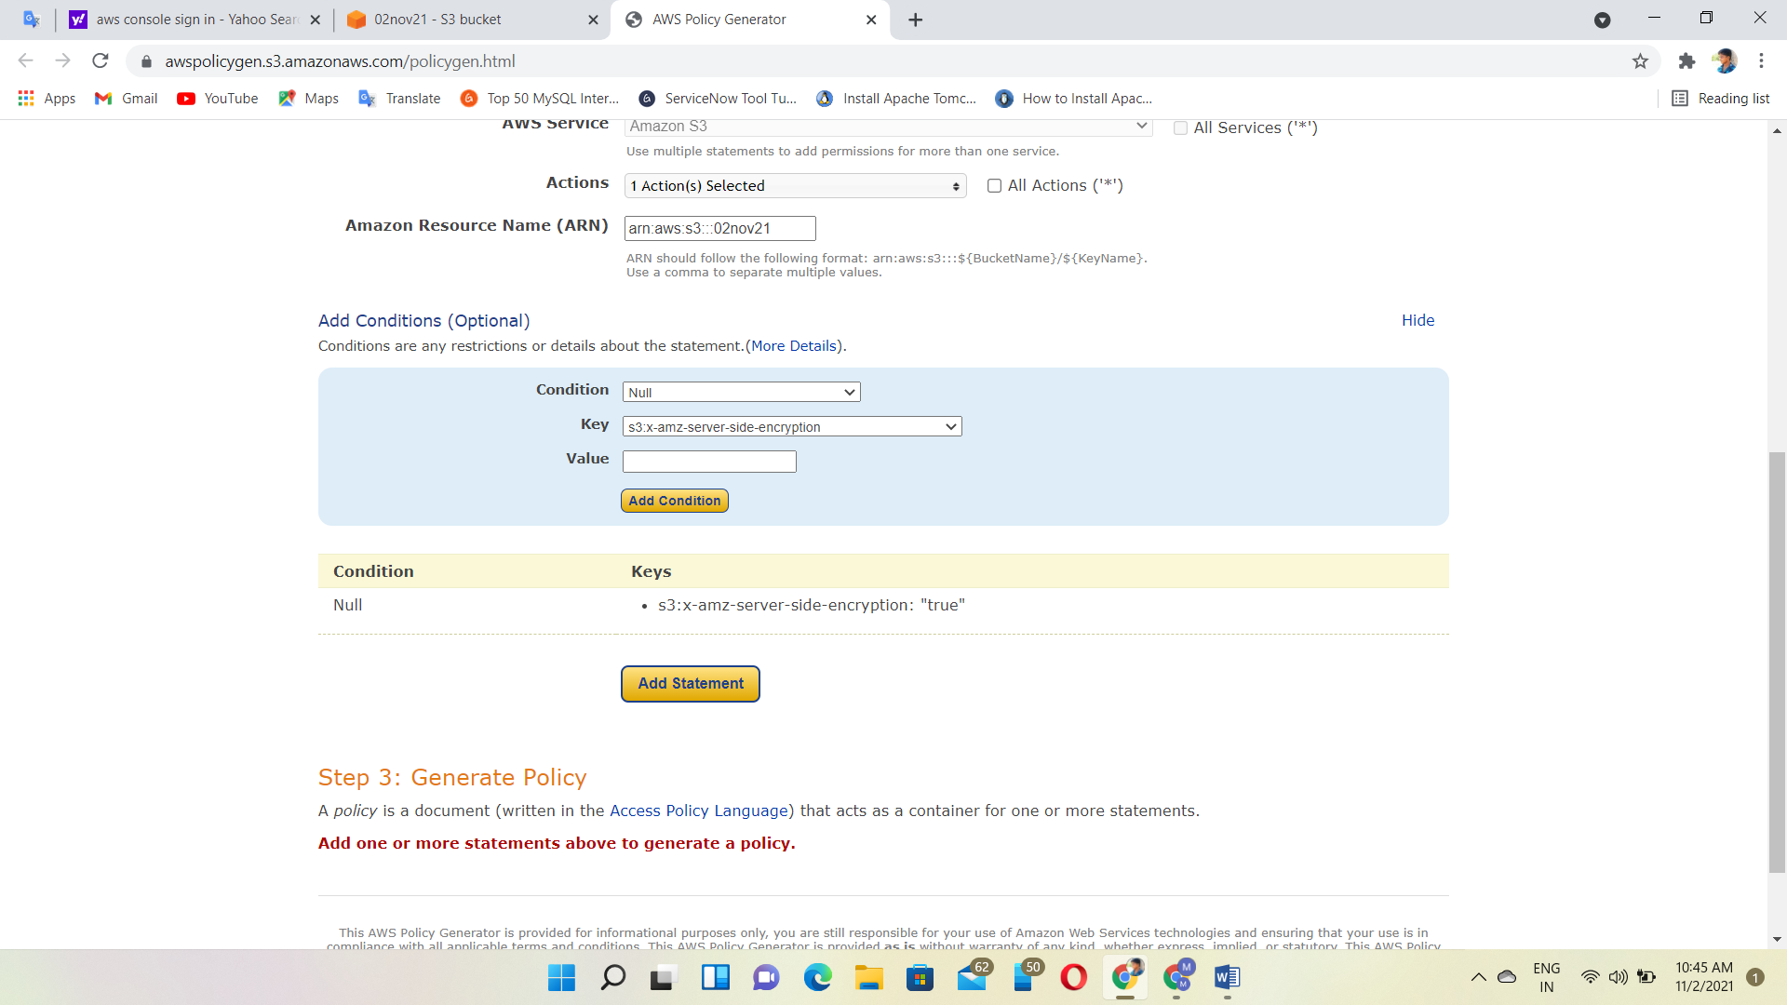

Finally, generated the policy

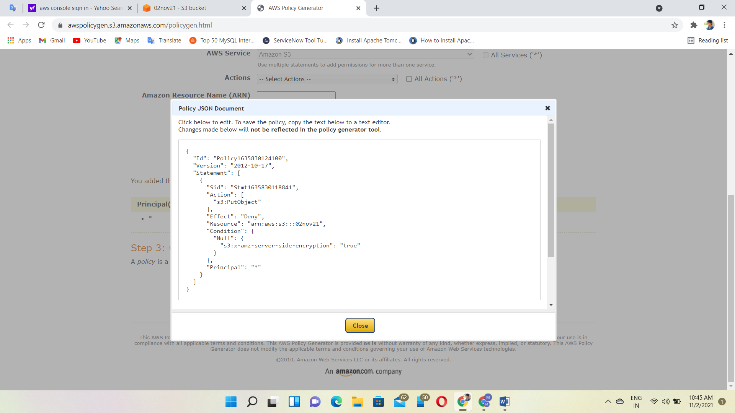

Then, copy and paste the policy

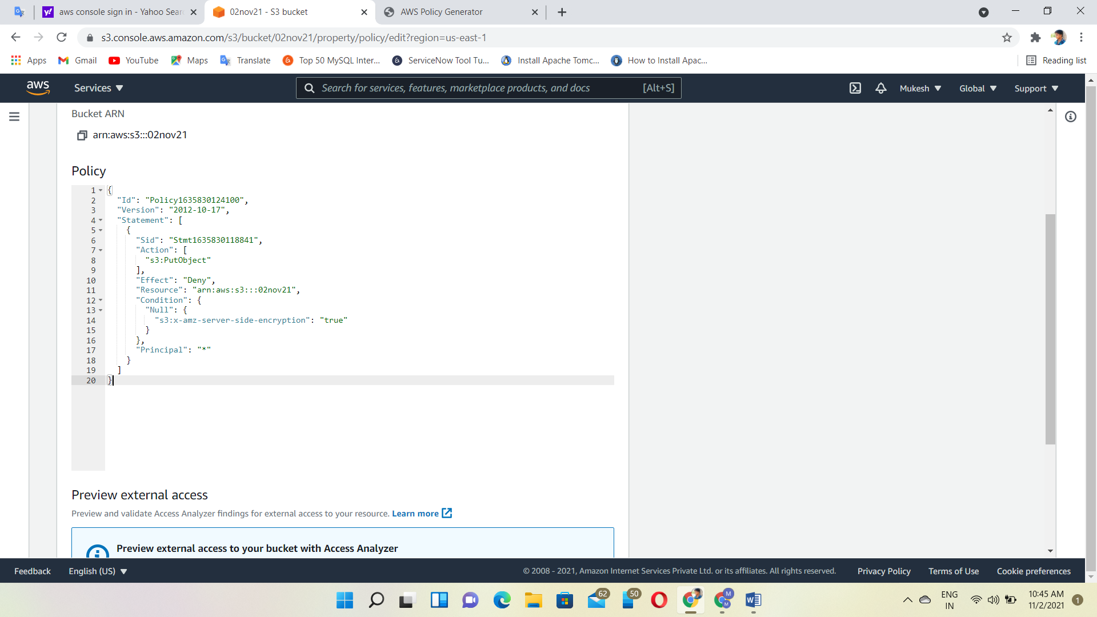

Bucket policy uploaded successfully

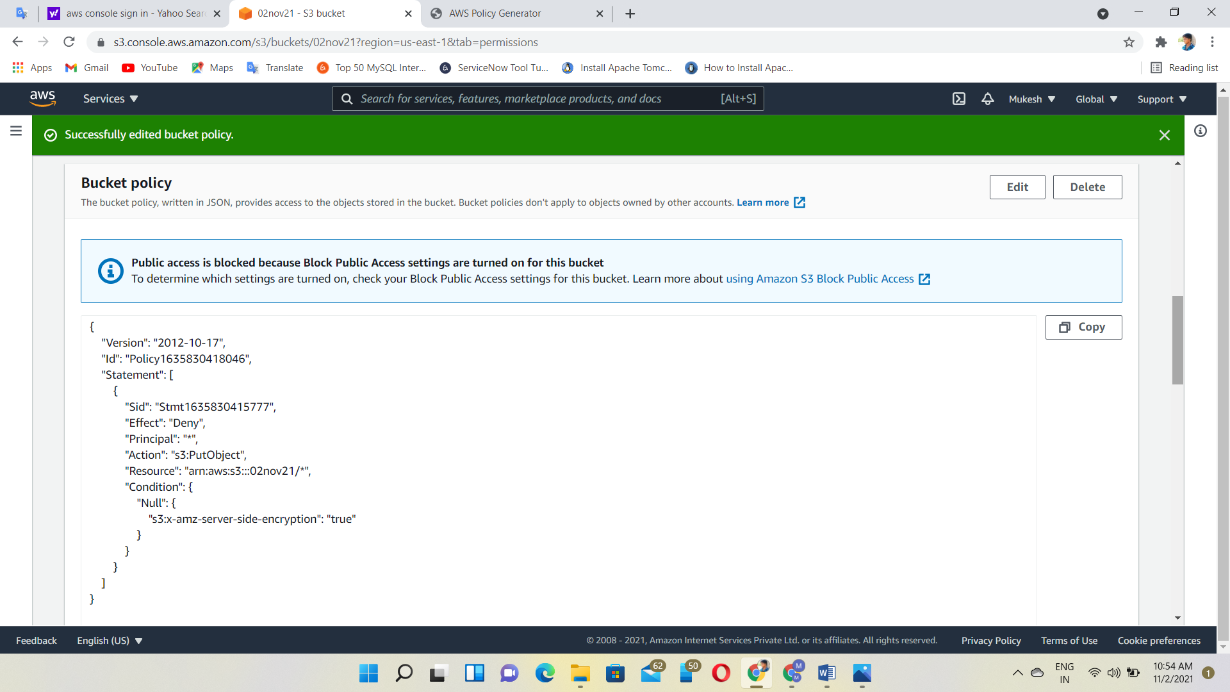

Then, upload the file again

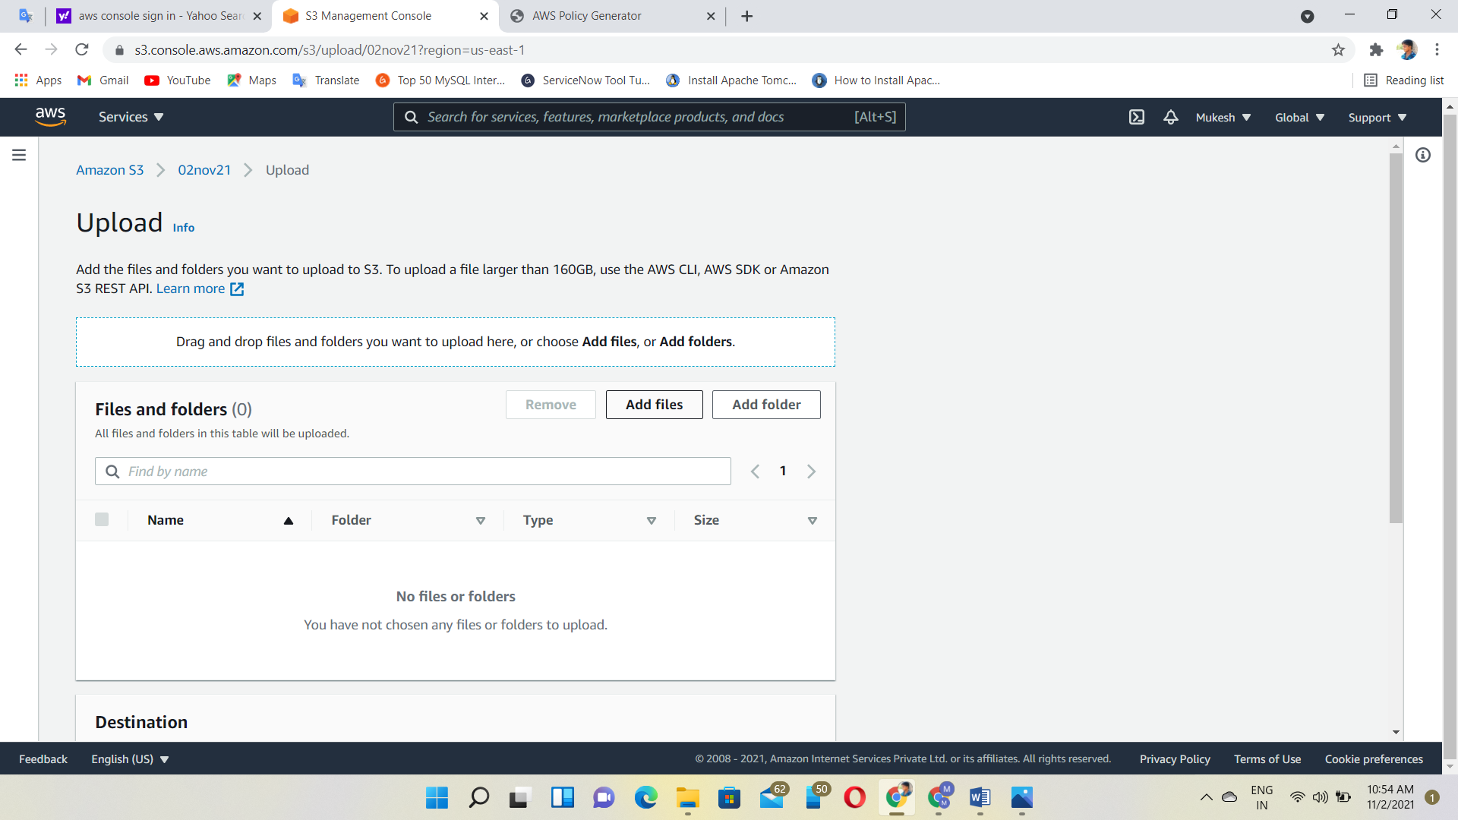

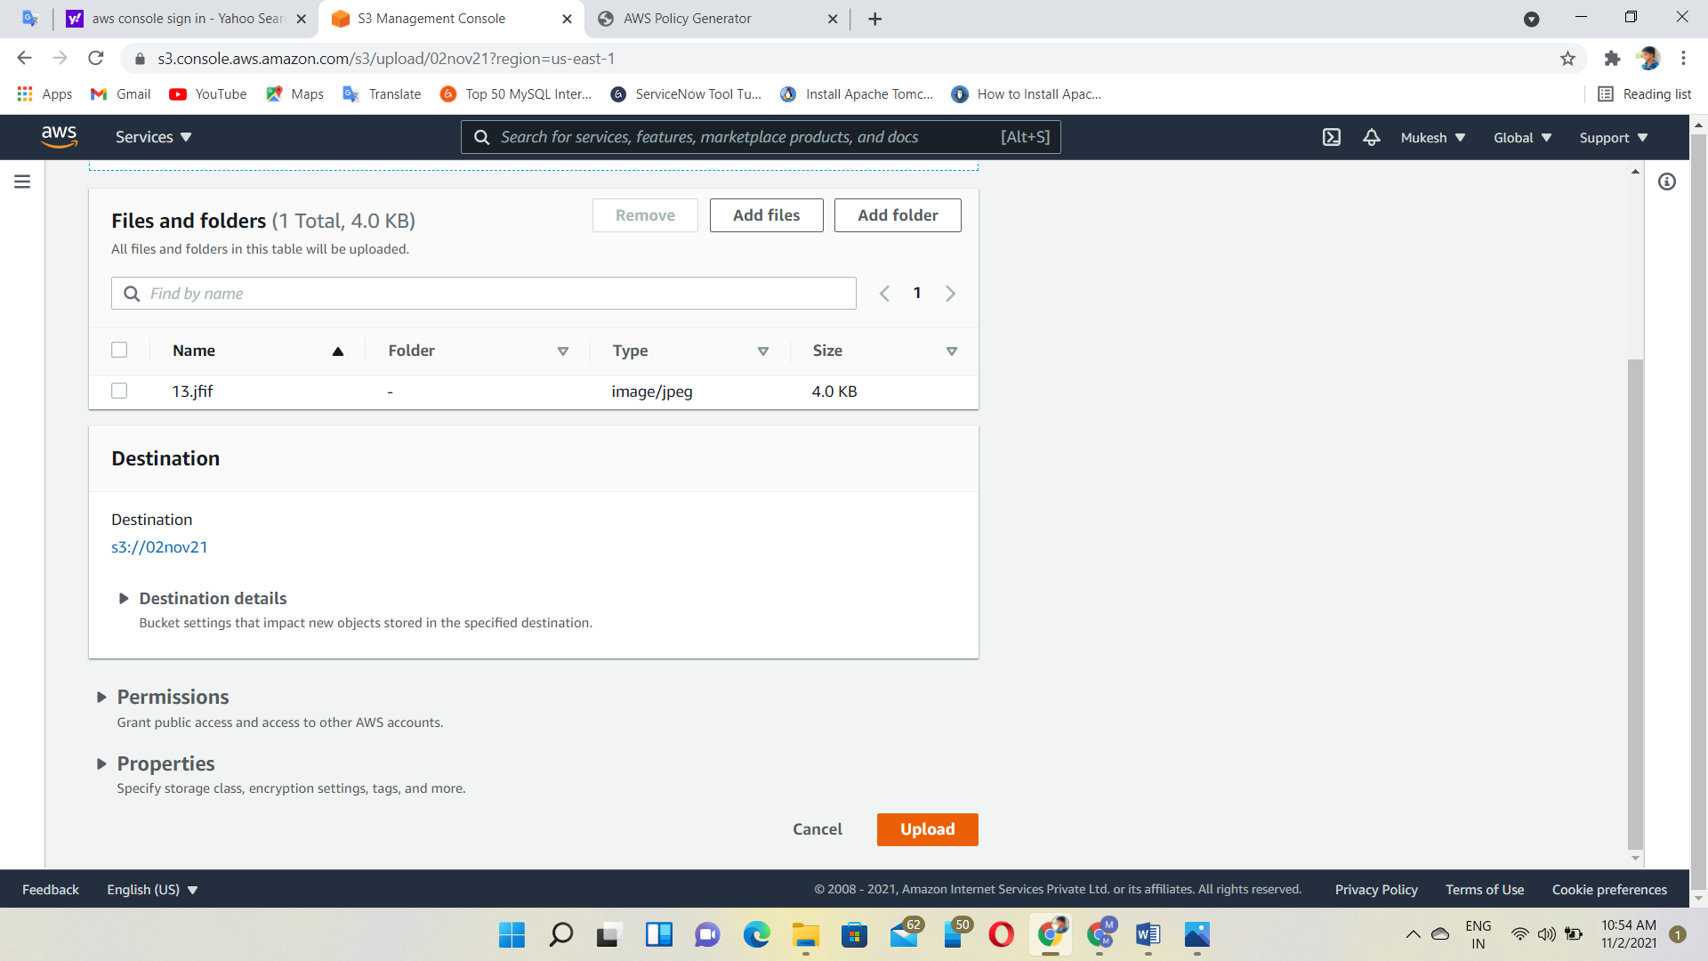

Uploaded failed

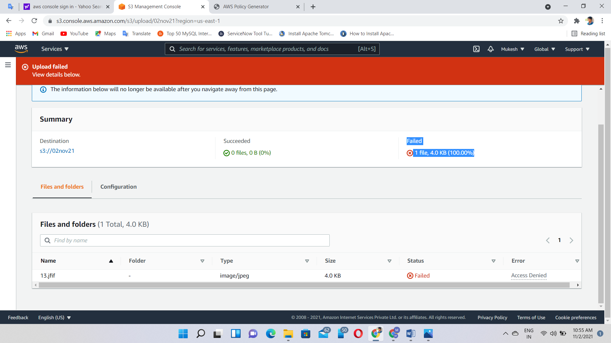

According to our policy, specify an encryption key in server side encryption settings

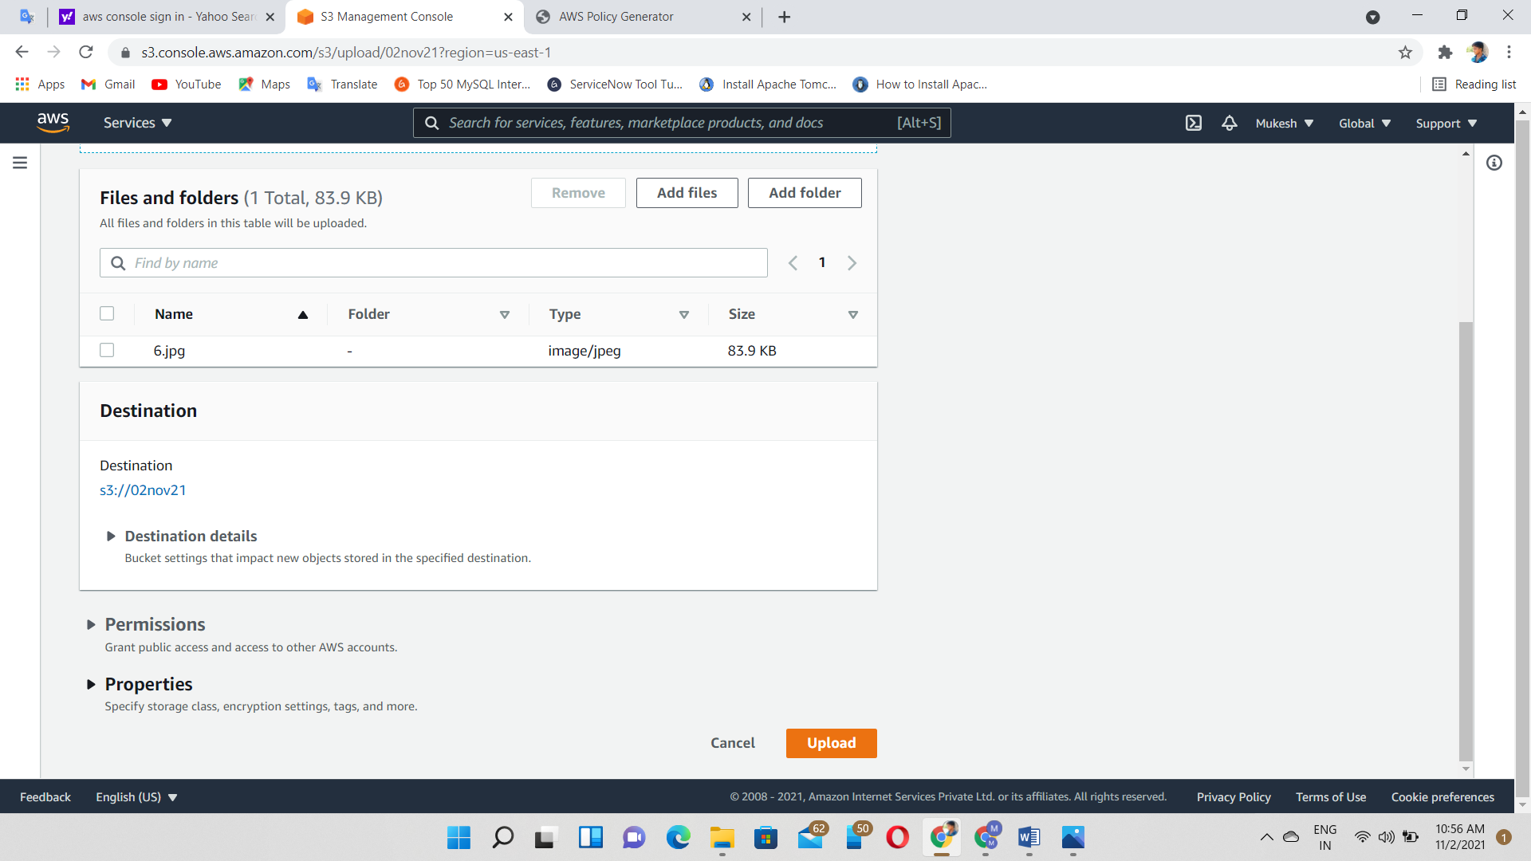

Select encryption keys

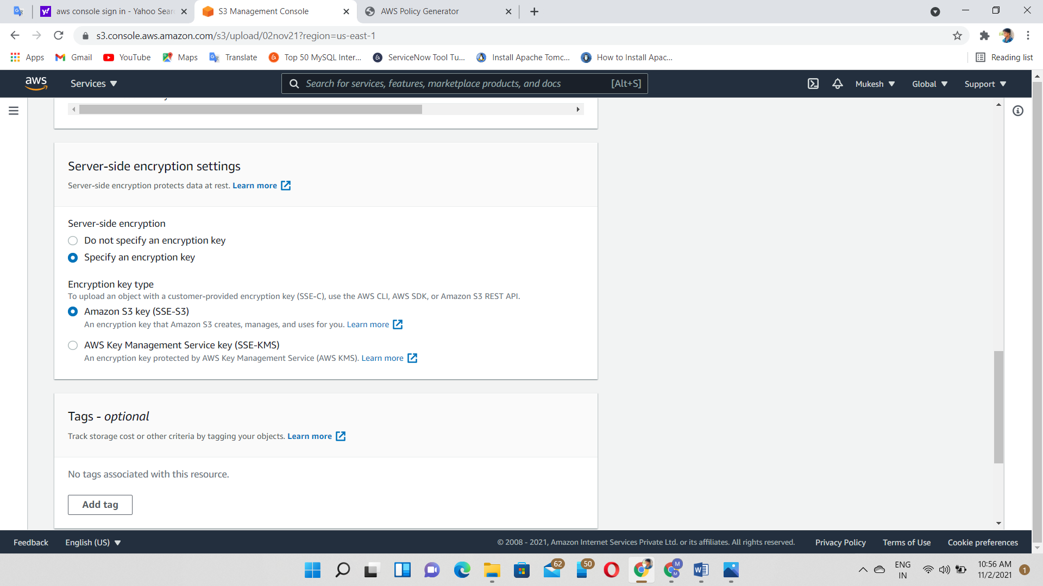

Now, files uploaded successfully

